Installation Guide

- Visit the Releases page of the project repository on GitHub: Releases · aurexis-au/remittance-splitter-releases · GitHub
- Download the latest version of Remittance.Splitter.Zip from the GitHub releases page. 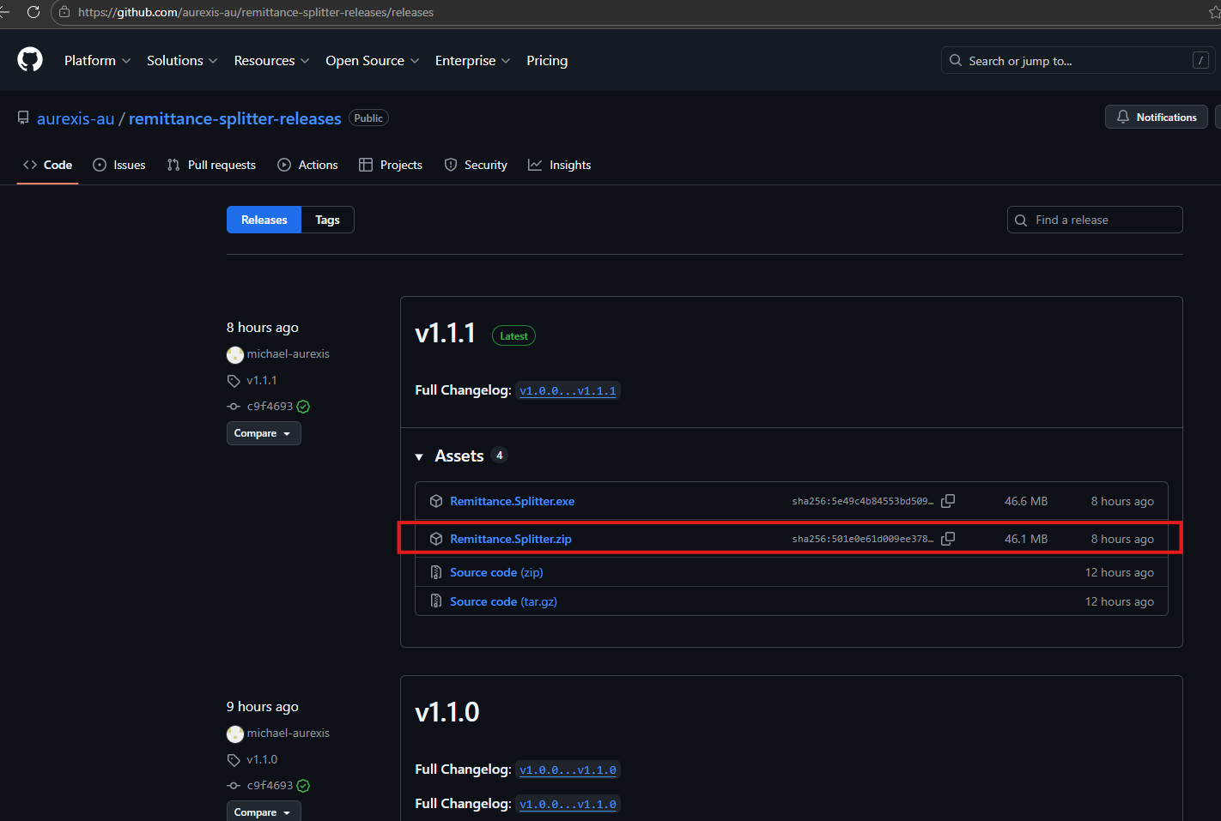
- Extract the contents of the ZIP file and run the executable (EXE) inside.
- You may see a message from Windows Smart Screen as shown below. 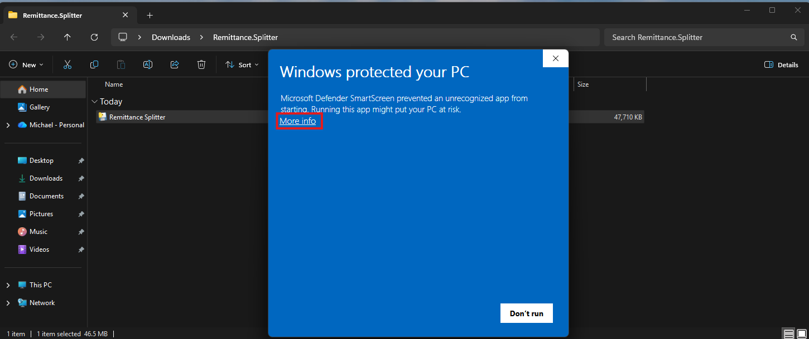
- Click on 'More info' and then select 'Run anyway' to proceed.
- The application should now start and you will see the main interface. 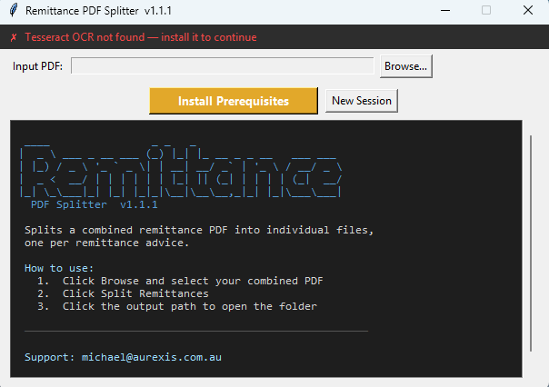
- Install the required dependency (Tesseract OCR) by clicking on the amber button. The installation may take some time the first time. You will also need to approve the installation of Tesseract OCR during the process.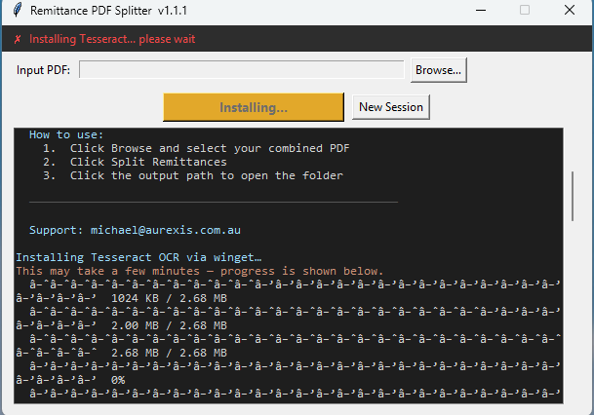
- Once the installation is complete, you will see a screen displaying all installed dependencies. You are now ready to start a new session by clearing the log and uploading a PDF file to begin splitting remittances.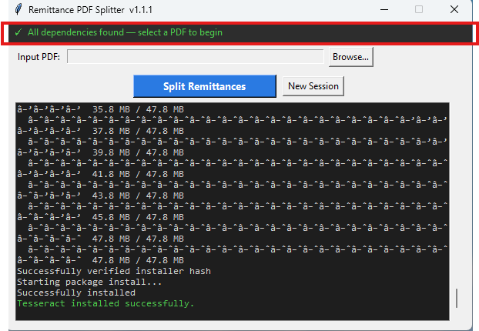

Disclaim: The warning appears because the application has not been digitally signed by a recognised publisher, which incurs an annual cost of several hundred dollars. The developer assures that this software has been created with no malicious intent and is intended to provide functionality for the benefit of users. While every effort has been made to ensure the software's safety and functionality, the developer makes no warranties or representations regarding its performance and accepts no liability for any issues that may arise from its use, including, but not limited to, data loss, system failures, or other damages.
Tesseract OCR is an open-source Optical Character Recognition (OCR) engine that can recognise and extract text from images or scanned documents. It is widely used for various OCR tasks and supports over 100 languages and scripts, including the ability to handle custom language models and training for new languages. Tesseract is completely free and open-source, maintained by Google, and offers powerful text extraction capabilities, converting printed or handwritten text from images (including PDFs) into machine-readable text. It can process multi-page documents, making it ideal for handling entire documents, and supports image preprocessing techniques such as binarisation and noise reduction to improve accuracy.

